**“SMART GARBAGE COLLECTION SYSTEM”**

**Vivek Khadiwale1, Parteek Singh2, Amol Mugale3 , Dipak Warade4, Mrs. Swati Aswale5**

**Underdipoma student,Department of Electronic &Telecommunication Dr. D. Y. patil polytechnic(Akurdi),pune,Maharashtra,India.**

**Assistant professor,department of Electronics & Telecommunication**

**Dr. D. Y. patil polytechnic(Akurdi),pune,Maharashtra,India.**

**Abstract:** - Smart garbage collectionsystem collects the garbage separately such as dry garbage to separate container with the help of pipe and separate wet garbage to separate container. The display is used to show the container level in percentage. If the container is full at that it will detect by sensors and message is sent to the nearest municipal office through the GSM module.

Hence the smart garbage collection system can be used in smart cities to collect the garbage separately (dry/wet).And it will help to prevent the environmental pollution.

**Keywords**- Separate garbage ,smart home ,wireless

**I**. **INTRODUCTION**

The mixing waste management is a big challenge in the any country. The smart garbage collection system is used of the smart home and smart city. The system is used of the separate garbage such as dry garbage is separate container and the wet garbage is separate container with the help of a motor mechanism and the IR sensor though. The garbage is place of motor mechanism then the IR sensor detects and the moisture sensor is the find out the garbage is wet or dry. Suppose the garbage is wet then the motor mechanism is rotated to left side and if the garbage is dry then motormechanism is rotated of right side and the garbage is collected in the container. when the garbage container is full then it will display to the nearest municipal office that the container is full and send the code or address. And the municipal office will inform of the garbage collector driver via sms through GSM module .The total process is wireless through.

**II. Transmitter block diagram**

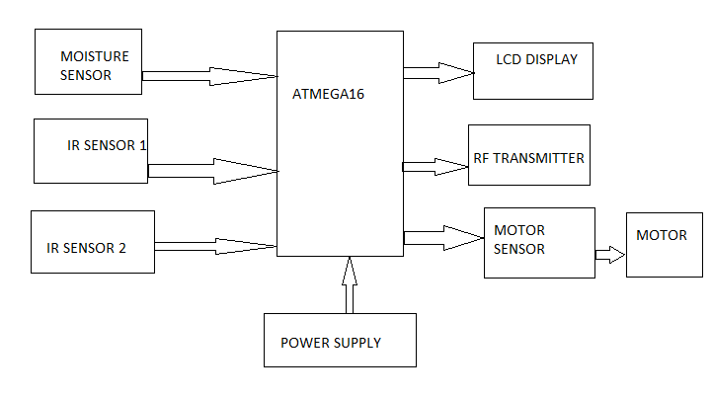

**HARDWARE DESCRIPTION**

**1. Power Supply:**

The 5v power supply is connected to the microcontroller.

**2. Moisture Sensor**

The moisture sensor measure the volumetric water content in object .If the garbage is liquid the moisture sensor the garbage pass the liquid container with the help of microcontroller.

The moisture sensor output is connected is the controller.

**3. IR Sensor**

An infrared sensor is an electronic device that emits in order to sense some aspects of surroundings. An IR sensor can measure the heat of an object as well as detects the motion.

The IR sensor is output is connected the controller.

**4. LCD Display**

The LCD Display is used to display of the container percentage and to show the container full indication. And is also connected the controller.

**5. RF Transmitter**

The RF transmitter is connected to the controller and the pass the RF signal to other controller.

**6. Motor sensor & motor**

The motor sensor connected the motor and the output is connected to the microcontroller.

**III. Receiver block diagram**

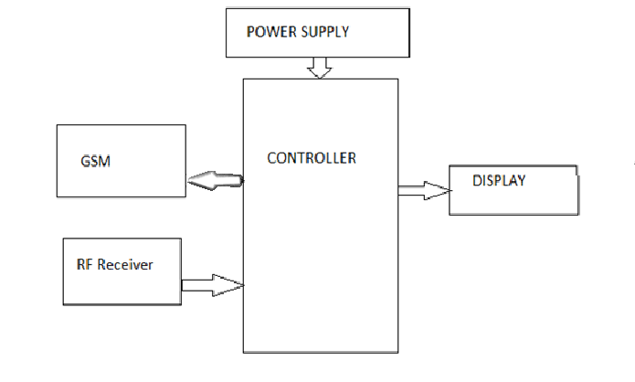

**HARDWARE DESCRIPTION**

The receiver part is connected the RF receiver, GSM, Display, Power supply.

**1. RF receiver**

The RF transmitter pass of RF signal and the RF receiver receive the RF signal & applied of microcontroller.

An **RF module** (radio frequency module) is a (usually) small electronic device used to transmit and/or receive radio signals between two devices.

**3. GSM**

The GSM is used the pass the messages of other phone with the help of microcontroller.

The GSM services are handling of only receiver section. The microcontroller is handling of GSM services.

**4. LCD**

The LCD is used the only RF signal messages with display form. Display of the container percentage and to show the container full indication.

LCD (Liquid Crystal Display) screen is an electronic display module and find a wide range of applications. A 16x2 LCD display is very basic module and is very commonly used in various devices and circuits.

**Algorithm:**

1. Start

2. Initialise hardware

3. Check moisture, not moisture

4. Check IR sensor 1&2

5. Transmitter signal of PCMC

6. Recieved the signal

7. Display of message in LCD

8. Message send the garbage VAN driver mobile with address

9. Stop

**ADVANTAGES:**

1. Collects garbage separately.
2. Low cost.
3. On time delivery.
4. Save fuel and manpower.

**DISADVANTAGES:**

1. Complex construction.

**APPLICATIONS:**

1. Can be use in formation of smart cities.

2. Can be use in colony, societies and hotels in future.

3. It can be use in large industries.

4. Used to deposit nuclear waste.

**REFERENCES:**

1. T.C.G. on behalf of the global esustainability initiative, The ICT behind cities of the future, SMART 2020.

2.N.Komninos:Intelligent cities: Innovation,knowledge,and Digital spaces 2002.

3. Kunzmann K. R.,smart cities: A new paradigm of urban development.Crios,1/2014.